The Demo should run in any case with S4H_FIN. However, as more and more do use this user a splash screen may come up telling you someone else has logged on already and need a choice. The LOGON Workflow covers such exceptions but it’s not a nice message for customers and may distract. Hence you may want to create your own user.

Here is how…

1. **Logon to SAP as one of the demo users (works well with S4H_FIN)**

Enter transaction code (TCODE) **SU01**  
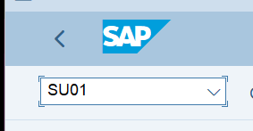

1. **Copy an existing user**

Click on “**Copy**” or use keyboard shortcut “Shift+F5”  
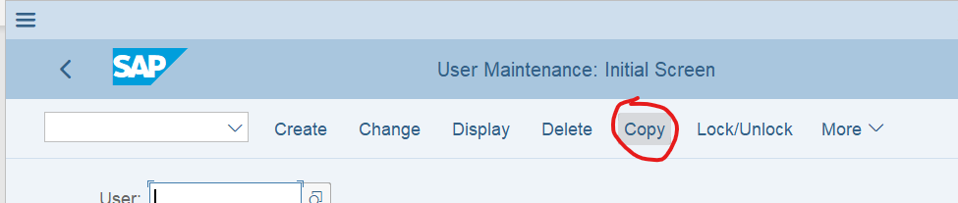

1. **Enter source user-id and new user-id and click on “Copy”**

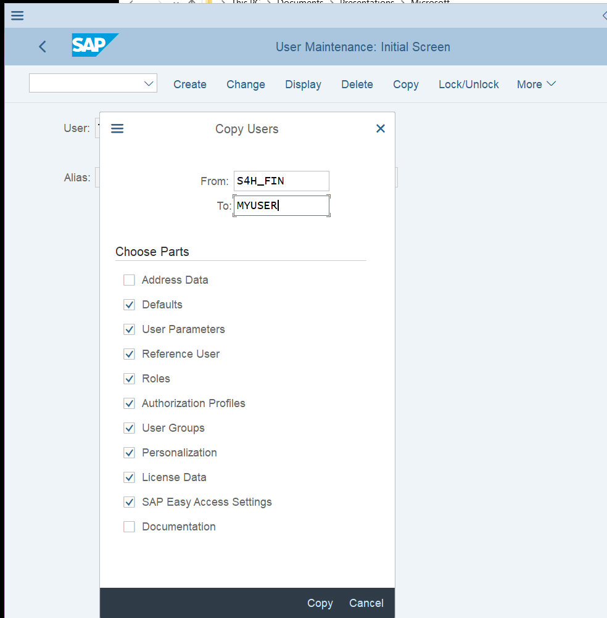

1. **Add default Company (BUK) for transactions**

Select the tab Parameters and add a new line to the parameters table. Parameter ID = BUK, Value of the default Company = 1710 (The SSD Workflow is optimized for that)

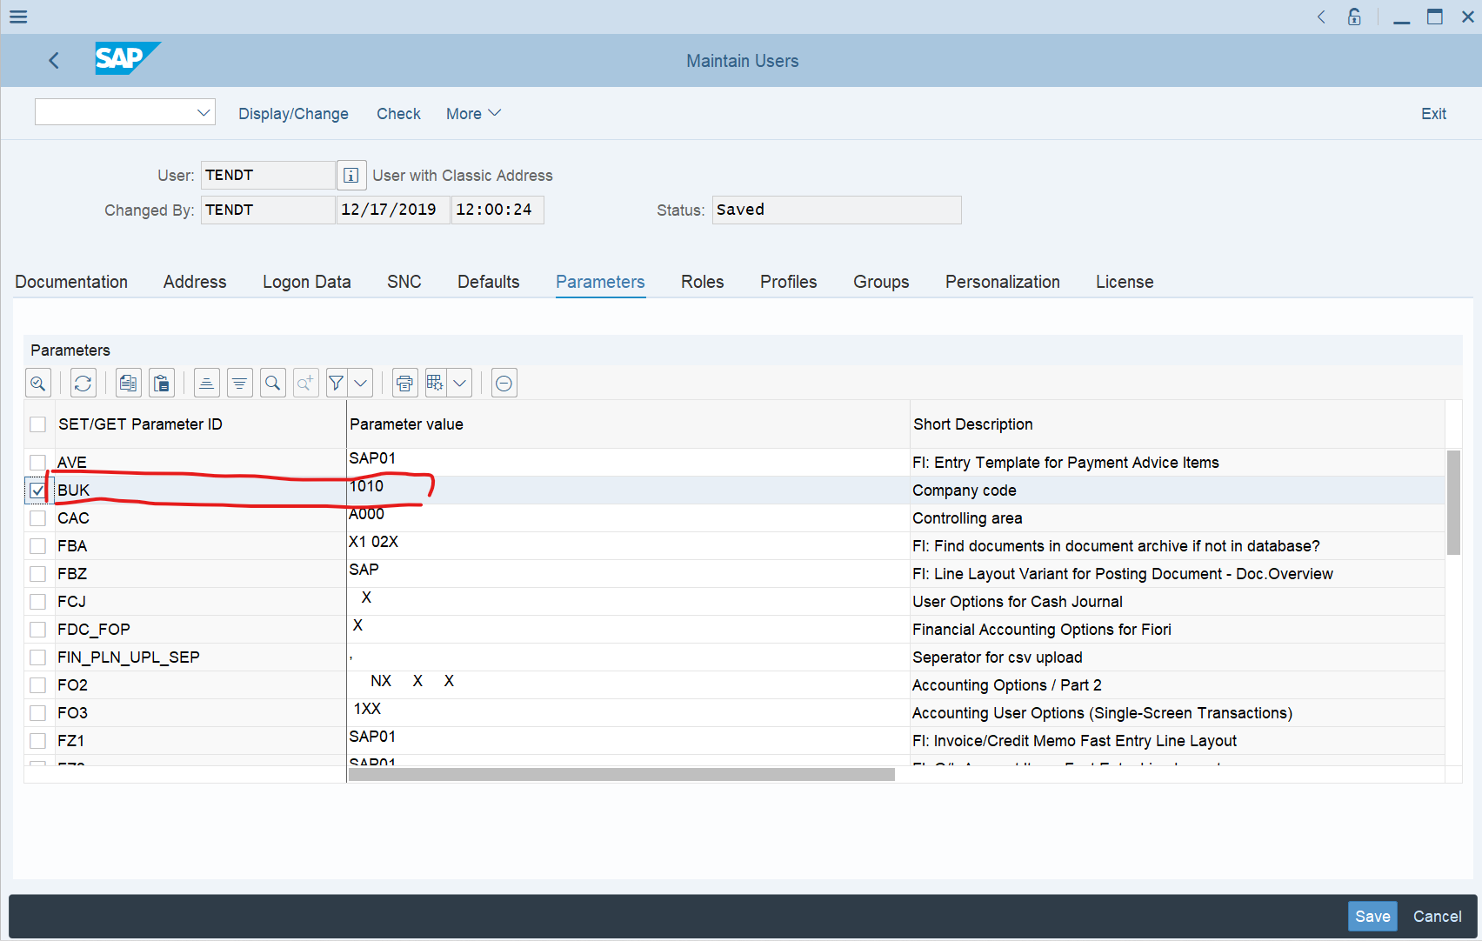

1. **Set your initial Password**

Select the tab “Logon data” and provide the initial Password. If you have a default Password for running the flow later in mind, do *not* enter now, as with the first Logon you need to change it again.

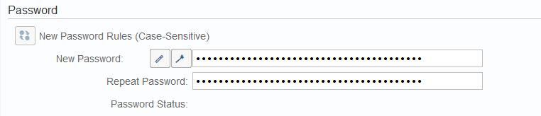

1. **Logoff from current and first Logon with your new User**

When you Logon the first time, you need to change your initial Password. The once logged on, you need to adjust one more thing

1. **First time with your new user logged on – Change F4 help**

Select on the main menu “More > Help > Settings” and then check if System Defaults are selected or check “Control-Amodal”. As otherwise some screens have different Titles and selectors may not work.

